DIRECTIONS TO THE PARTY
The party is held at Abbots Wood, in Arlington village, west of Hailsham. The nearest postcode is BN20 6SJ but won’t leave you at the entrance.

From the Boship Roundabout go south on A22 towards Eastbourne, go over the next roundabout, then at the brow of the hill turn right on to Arlington Road West. After about a mile, turn left towards Arlington and Abbots Wood.
Past the Old Oak on the right, past Tye Hill Road on the right, then it’s about 200 metres on the left hand side.

From the Cophall Roundabout on A27 / A22, go north on A22 towards Hailsham. Go over the next roundabout, then at the brow of the hill turn left on to Arlington Road West. After about a mile, turn left towards Arlington and Abbots Wood.
Past the Old Oak on the right, past Tye Hill Road on the right, then it’s about 200 metres on the left hand side.

From the A27 at Wilmington, take Thornwell Road heading north (with the Downs behind you), sharp right into Bayleys Lane, and at the end of this road turn right and Abbots Wood is the first turning on the right.

Information about the site can be found here: www.forestryengland.uk/abbots-wood

Please note the parking charges: £2.30 up to 2 hrs /£3.50 up to 4 hrs /£4.60 all day

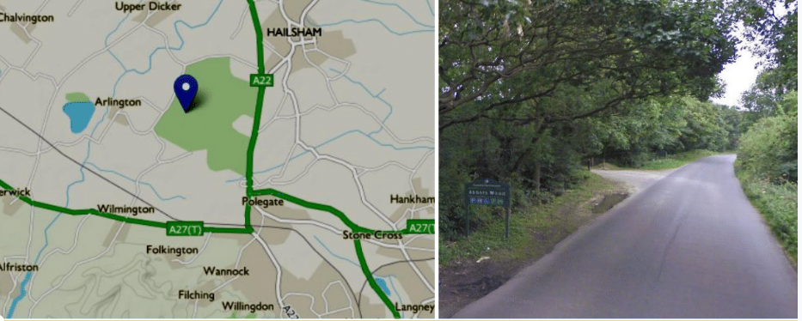

Other details: You can dress up, if you like, but long trousers / leggings and closed toe shoes are essential
against scratches and bitey insects, together with wellies or boots and waterproofs if it’s wet. There are toilet facilities in the wood.
Please let us know if your child has any dietary requirements, allergies or other needs we should know.
See you in the woods!

